# Project Title

Smart School System Portal for Students and Parents

# Introduction

Smart School System Portal is an interactive system for students and parents for keeping track of all the events being held in school and parents can keep track of their children curricular activities as well as their performance in each subject. They don’t have to come to school for each complaint and problem about their children; they can simply inform it through portal. Administrator will respond to their complaint or leave if it is feasible. Smart school portal is providing a platform for parents to be a part of their child curriculum completely. It will provide attendance record, result record based on each term and final result record.

# Business Rules

* Parent and student can view events of school information.
* Only student can registered in school events for event tickets.
* Only those parent have ID whom their children have admission in school.
* Only administrator can approve and disapprove leaves.
* Only administrator can change, verify and update student class ,section and registration number
* Parents can register their children in a class and its subject which can be managed by administrator and viewed by parents and student.
* Students and parents can view subject wise marks on official account which are managed by administrator.
* Student marks report viewed by student her/himself and her/his parents and approved by administrator.
* Subject wise total marks report of whole class viewed by students, parents and approved and managed by administrator.
* Term wise marks report and individual student term marks report viewed by student, parents and approved and managed by administrator.
* Whole class report viewed by student/parents and managed by administrator.
* Attendance report for each student can view by student /parents and approved by administrator.
* Whole class attendance report can be managed and approved by only administrator.
* Parents, admin and student once added cannot be deleted from database.

# Conceptual Diagram, ER Model

ER Model in PDF Format can be found [Here](https://www.dropbox.com/sh/hpavkpmowl60s0m/AADyYrrAI6QiwSc3FUtb09MHa?dl=0) if it’s not visible completely.

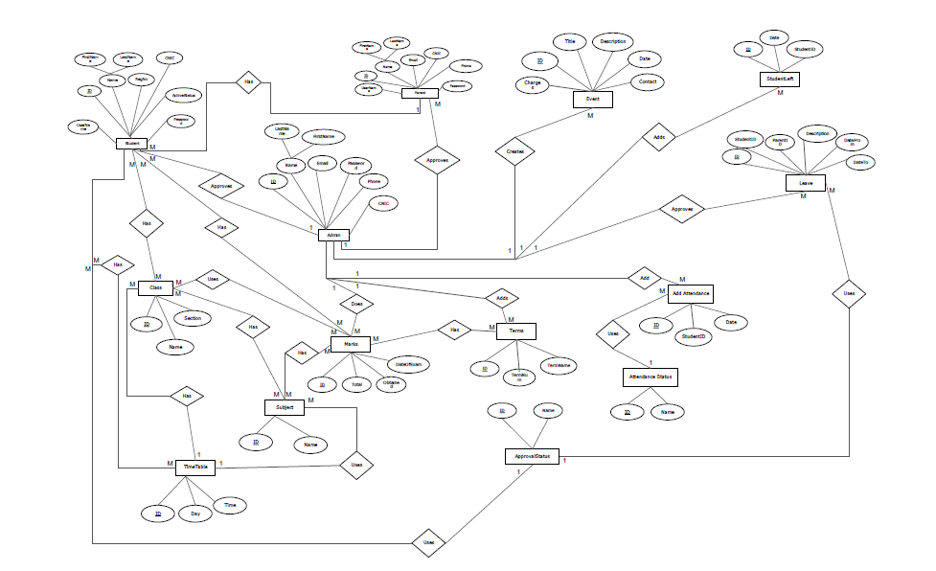

# Database Design (Diagram)

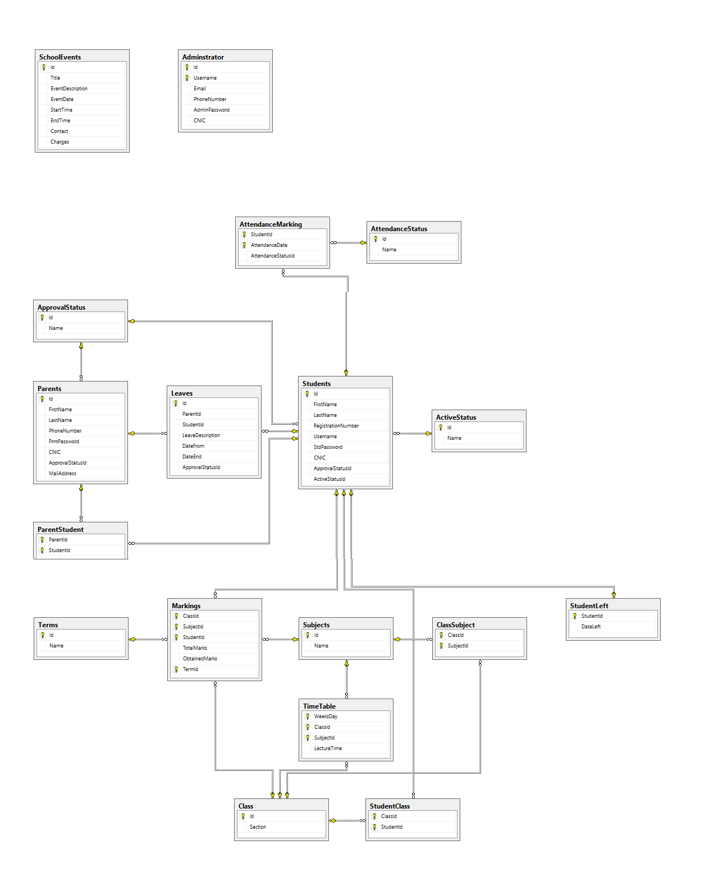

# Reports

* School Events Report.
* Leaves Status Reports. (Approved, pending and Unapproved) (For administrator only)
* All the Students in School with their class specification. (For administrator only)
* All the Students in a class. (For administrator only)
* All the Students in a section. (For administrator only)
* One student Registered in all the subjects recently. (For administrator, parents and student)
* Subject wise marks report for each student. (For administrator, parents and student)
* Total marks report for each student. (For administrator, parents and student)
* Subject wise marks report for whole class. (For administrator, parents and student)
* Total marks report for whole class. (For administrator, parents and student)
* Term wise marks report for each student. (For administrator, parents and student)
* Term wise marks report for whole class. (For administrator, parents and student)
* Timetable report for each class. (For administrator, parents and student)
* Class result report. (For administrator, parents and student)
* Attendance Report for each student. (For administrator, parents and student)
* Attendance Report for whole class. (For administrator only)

# Technology to be used

* Visual Studio MVC Web based application using ASP.NET
* Crystal Reports library for creating reports.
* SQL Server 2014 Management Studio for Database.